Fireworks

Did you know?

About firing fireworks

In a big display, some fireworks are set alight or 'fired' by hand and others electrically. Each firework has a fuse made from 'black match'. This is cotton thread soaked in blackpowder (gunpowder) and gum arabic, a resin which sticks materials together. The black match can be coated in paper to make 'piped match'. Piped match and black match can be lit with a handheld splint called a 'portfire'. For electrical firing, a wire is connected from the fuse to a fusebox. (This is not the same as the fusebox in a domestic circuit.) A high current is sent down the wire at the right time, causing enough heat to light the fuse. When there are lots of fireworks to fire, correct timing of the currents is important, so experienced fireworks demonstrators use a computer program to help coordinate the firings and make the effects as planned.
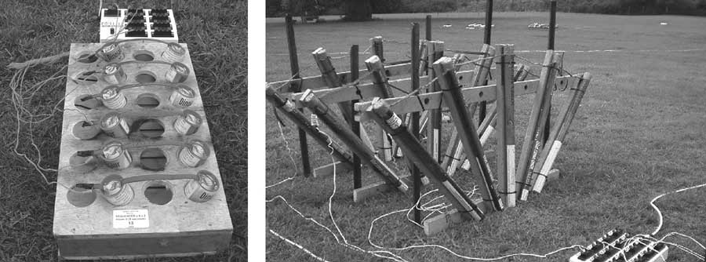

Electrical firing systems for fireworks displays
Reproduced with kind permission from Mat Lawrence, MLE pyrotechnics Limited, www.mlepyrotechnics.co.uk (accessed November 2003)



